**Flags for Follow-Up and Pinned Items**

You can put a flag for test plan, test sets, requirements, defects

Lets see how it works for defects

Go to defects and select the defect you want to flag

Then click on flag icon

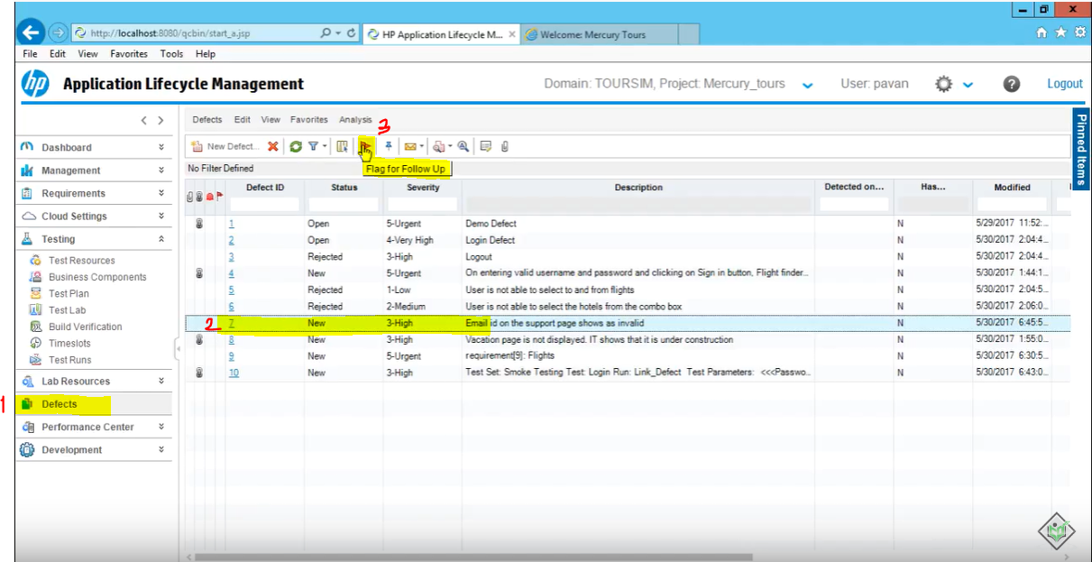

Enter flag description, click on ok

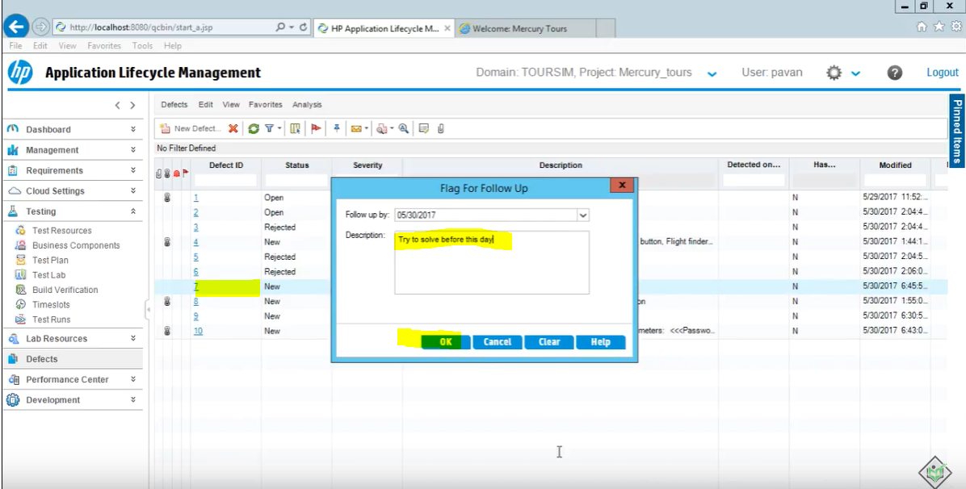

An email will be sent to the person this defect is assigned to, to notify there is a flag on this defect

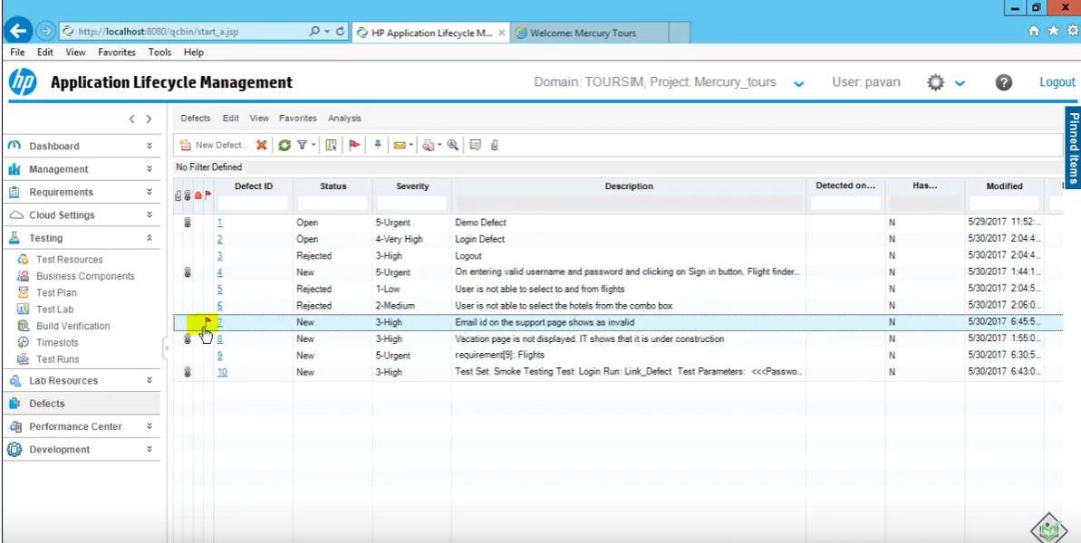

Flag color will be red if the flag is for today (due date)

But if you put a flag for a future date it will be a grey flag



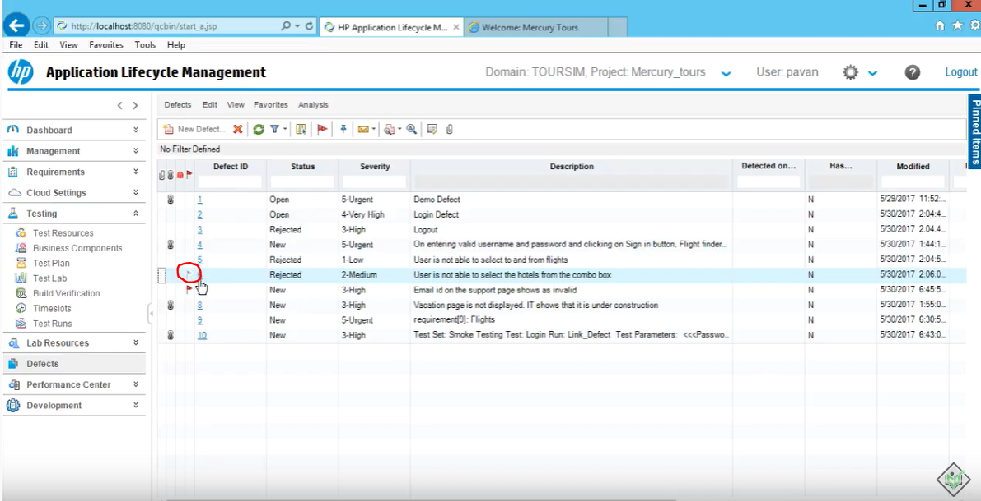

When due date comes it will turn to a red flag

**Pinned Items**

When you are working for a big company, your project will have so many requirements or tests

And each time when you open ALM to get to certain requirement or test plan

You have to go thru the entire list and find the exact one you want to open.

In this case you can use pinned items.

You can add certain requirements, test plans or whatever it is that you use frequently

You pin those to the pinned items list and when you open ALM you can get to those with one click instead of searching them each time

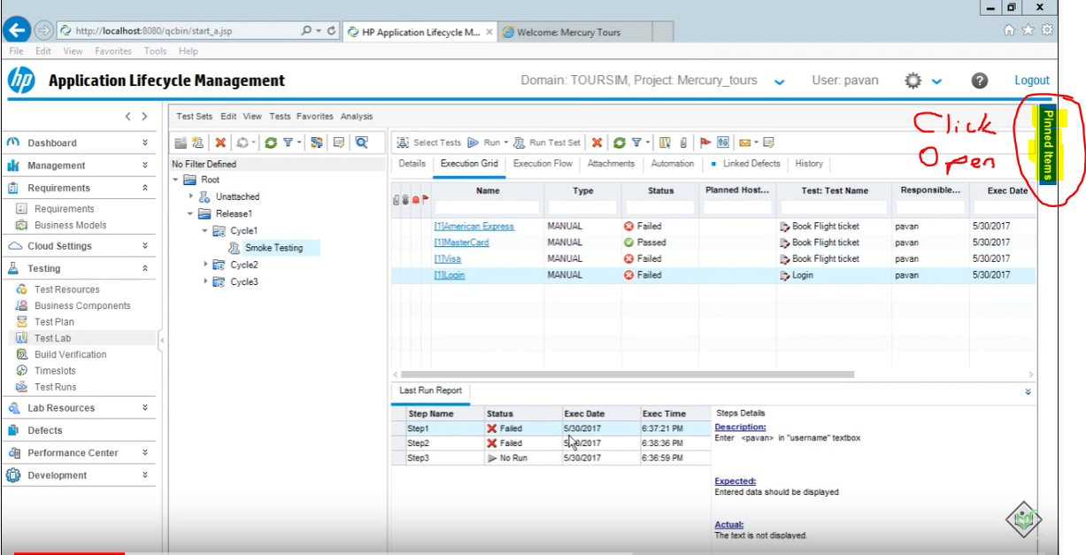

Select the requirement you want to pin and click on pin icon

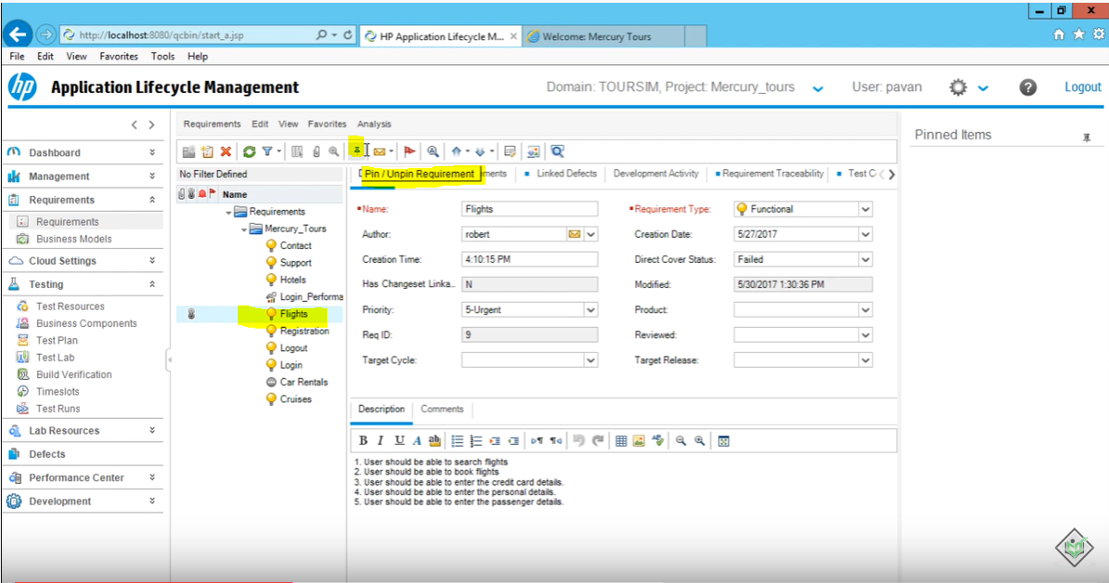

It will add it to pinned items

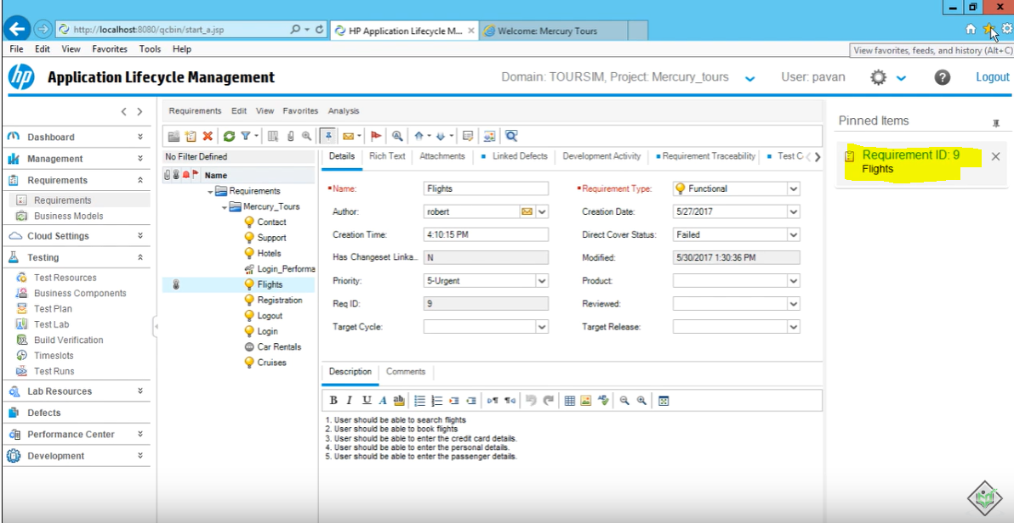

Same way you can pin test or defect

